

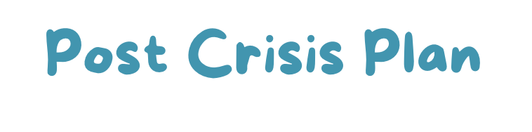
&



This Crisis Plan and Post Crisis Plan help you plan what to do in case of a crisis and when recovering afterwards.
Simply having these in place can help put your mind at ease (and even help avoid a crisis).
They are ‘collaborative’ plans. That means they are best made with others who might care about you and support you. This means everyone is on the same page to support you in case of crisis and in recovering afterwards.



What I’m like when I’m feeling well:


Symptoms. Symptoms that indicate to others that they need to take over responsibility for your care and make decisions on your behalf:

Supporters. Try to list at least five people you chose to to take over for you when the symptoms you listed come up. Include the role you want them for them in your plan:

Name | Phone | Relationship | Role In My Crisis Plan


Medication
List your physicians, consultants, pharmacies and their telephone numbers:
Name | Tel


List any allergies you have:

List any medications you are currently using and why you are taking them:
Medication | For


What medications you would prefer to take if medications, or additional medications, became necessary and why you would choose them:
Medications I would Prefer to take | Why

List any medications that you would like to avoid and jot down why:
Medications I do NOT wish to take | Why


Treatments
List treatments that help reduce your symptoms when you are in a crisis:
List treatments you wish to avoid:

Home/Community Care/ Respite Centre

Set up a plan so that you can stay at home or in the community but get the care you need:


Treatment Facilities

List treatment facilities where you would prefer to be hospitalised if necessary:

List treatment facilities you wish to avoid:


Help From Others
What can your supporters do for you to help reduce your symptoms:
What practical things do you need others to do (feed pets, get the mail etc):
List things that supporters might do that could worsen the situation
(like being impatient, invalidation etc):

When My Supporters No Longer Need To Use This Plan

Make a list of indicators that your supporters no longer need to follow this plan:


If I Am In Danger. If my behaviour endangers me or others I want my supporters to:


I will know I am ‘out of crisis’ and ready to use this post crisis plan when I am able to:

How would you like to feel when you have recovered from crisis?
Look at the section where you described what you are like when you are having a good day, although this list might differ:


Supporters
I would like the following people to support me if possible during this post crisis time:

Name | Tel | Relationship | What I need them to do

My Crisis Recovery Plan
What are some things you need to do every day while recovering from this crisis?
List things and people you need to avoid while you are recovering from this crisis:

If I start to Feel Bad
What are signs that you may be beginning to feel bad (eg anxiety, sleep disturbance)?

List wellness tools you will use if you start to feel bad. Star those that you MUST do - the others are choices:

List what do you need to do, when, to prevent any further repercussions from this crisis:
Signs That This Post Crisis Phase Is Over

List things to do for yourself every day:

List any changes to your crisis plan that might ease your recovery:

What did you learn from this crisis?

List any changes you want to make in your life as a result of what you have learned:
List any changes you want to make to your lifestyle or life goals:

If you do want to make some changes, when and how will you make them and track them?


Resuming Responsibility
A plan for how you will take back control for each role you gave responsibility to others to during crisis (eg feeding the pets)

Responsibility:

Who has been doing this:

Who needs to help now:
What do they need to do:

Plan for you Resuming Responsibility:

Responsibility:

Who has been doing this:

Who do you now need to help:
What do they need to do:

Plan for Resuming Responsibility:

Responsibility:

Who has been doing this:

Who do you now need to help:
What do they need to do:

Plan for Resuming Responsibility:

This Workbook belongs to:

Name

Address
Tel

Email:

I developed this plan on (date) :
With the help of:
Any plan with a more recent date supersedes this one.
Signed :
Date:
Witnessed by:
Witnessed by:

Attorney :

Enter details of Enduring Power of Attorney (if you have one):

